Country Natural Beef: A Maturing Co-op at the Crossroads

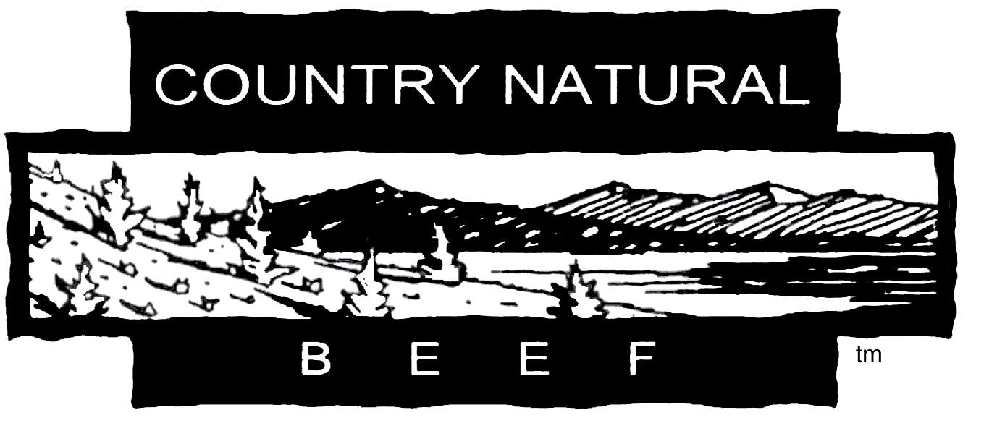

Mellie Pullman, Ph.D.
School of Business
Portland State University
Portland, OR 97207
mpullman@pdx.edu

Zhaohui Wu, Ph.D.
College of Business
Oregon State University
Corvallis, OR 97331-2603
wuz@bus.oregonstate.edu

Victoria Villa-Lobos
School of Business
Portland State University

Teaching Case for Sustainable Supply Chain Management

Acknowledgement: We thank many members of Country Natural Beef and its supply chain partners for their time and providing information for this case. We also thank Agriculture of the Middle (www.agofthemiddle.org) for providing funding for this study. The case data was collected between August 2008 and March 2010 through interviews.
One a warm day in late May of 2008, after a three hour drive, Stacey Davies eased his pickup into the gates of Probert Ranch in Vale, Oregon, near the Idaho border. As the new Marketing Internal Partner for Country Natural Beef cooperative, Stacey was paying a visit to Dan and Suzy Probert. While Davies routinely spoke to the Proberts on the phone, meeting in person was helpful in their new roles: Probert, the elected chairman and executive director of Country Natural Beef, and Davies, its new marketing manager. Country Natural Beef, which began in 1986 with 14 ranch families, was now an important player in the value-added beef industry. The co-op entered the natural food market in its early years and benefitted from a decade of rapid growth in this sector of the food industry.
Lately, the co-op’s members had been concerned about union problems at the feedlot, animal welfare issues and the stress of continued growth. During the previous summer, several ranchers had suffered financially from their cattle getting sick in the feedlot. Some of the cattle died; those that recovered could not be sold as natural beef at a premium price because they had been treated with antibiotics.
“You know,” said Probert, “these economic times aren’t too much different from when Country Natural Beef got started.”
Davies countered, “‘Decommodify or die’ still applies, but the world has changed. There’s a lot more cowboys playing our game; the rules are tougher.”
Probert nodded. “We always have to be cognizant of what our customers want, address animal compassion issues and find new market opportunities. But if this gets too complicated, we might also cause a lot of frustration for our members.”
Both men wondered what they could do to stay vital when recent sales had been flat, following many years of rapid growth.

The Cattle Ranching Industry

Industry Overview
In the commodity beef market, inputs and outputs are bought and sold along a well-established transaction path where price is largely determined by cost and individual cattle weight. The beef supply chain is highly fragmented. Approximately 750,000 cattle ranchers in the U.S. command $500 billion in annual revenue, yet only 5,000 ranchers own more than 500 individual head of cattle. The top fifty operators amount to less than two percent of the market (Beef Cattle Ranching, 2009).
On the other hand, the meat fabrication industry (that is, slaughterers, primary and secondary processors and distributors) is highly concentrated and earns annual revenues of $85 billion. The five largest beef processors controlled 78 percent of the market in 2007. Top firms include Tyson Foods, the largest slaughterer and beef products manufacturer; Cargill Meat Solutions, a diversified meat processor and distributor; and JBS-USA, the Brazilian corporation that recently acquired two major processors—Swift & Co. and Smithfield Beef Group (Johnson, 2009).
Feedlot operations in the United States are also highly concentrated, with beef processors including JBS-USA and Cargill owning some of the largest feedlots (Exhibits 1 and 2). The top five percent of feedlots in the U.S. market about 80 to 90 percent of the feedlot finished cattle. In 2006, the National Cattlemen’s Association reported that the 25 largest feedlots had a combined one-time capacity of 5.15 million head (Northwest Farm Credit Services, 2007), while 95 percent of feedlots have a one-time capacity of less than 1,000 head.

Cattle and Beef Supply Chain
The cattle and beef supply chain has five major links (Exhibit 3). Ranchers, or cow/calf operators, raise breeding cows and their young calves. The calves receive mothers’ milk and are weaned; the weaned calves graze on pasture and range land. Commodity beef is generally ranch-raised for six to nine months, when the animals weigh between 600 and 800 pounds. Some ranchers sell their weaned calves to stocker operators who graze the calves until they reach this weight. Typically, the full-grown calves are sold to feedlot operators in the Midwest (Iowa and Illinois) or high plains (Texas to Nebraska). There, they are fattened, or finished, on high grain rations for 120 to 140 days and slaughtered by packers at 1,200 to 1,400 pounds. Retailers are the final link in the beef supply chain.
Cattle producers often sell their livestock through local auctions or remote auctions conducted over video or the internet. Live cattle prices are negotiated based on sex, weight, genetics, health, location and estimated cost to finish. Truckload quantities of livestock with similar traits are purchased by feedlot operators to be delivered one to eight weeks in the future.
During the finishing phase prior to slaughter, diet has a strong impact on final meat characteristics such as flavor, tenderness and marbling. Feed rations during finishing are typically designed to realize three goals: 1) meat consistency across herds that were raised in various climates and fed different diets on the ranch, 2) weight gain maximization and
3) cost minimization. Diets can consist of forage (harvested or grazed herbaceous plants such as hay and alfalfa), corn and other grains, and vegetables such as potatoes. Though not the industry standard, cattle can also be finished on open pastures or in large, enclosed pens of various sizes, sometimes called bunkers, that provide more space per animal than typical feedlots. With feed as their highest direct cost, operators are concerned with feed efficiency, or the rate that feed translates into gained weight.
The forage quality of a range or pasture varies according to soil, terrain, rainfall and climatic conditions. Ranchers’ costs rise with the need to supplement their own available forage with purchased grazing rights on other land and/or feed supplements.
Feedlot operators seek to optimize production by leveraging economies of scale. Large-scale feedlots (100,000 to 200,000 head capacity) are known as concentrated animal feeding operations, or CAFOs, because they amass many animals into small spaces. Hidden and externalized costs associated with CAFOs have increasingly drawn scrutiny. Concerns about “factory farming” of livestock encompass food safety, animal compassion and environmental quality against the backdrop of globalization and increasingly complex supply chains. These concerns include the runoff of contaminants like E. coli from manure dumps near feedlots into proximate rivers, streams and groundwater.
Animal welfare issues have moved into the mainstream in recent years. Hot topics include stressed animals confined in poor living conditions, the incompatibility of high corn diets with bovine digestion and the trucking of cattle over long distances, all of which can translate into more sickness, antibiotics, vaccinations and premature death. A body of work by Temple Grandin (2008), an animal scientist at Colorado State University, includes research into bovine behavior and the effects of stress associated with factory farm production. She details optimum methods to minimize cattle fear and injuries during especially hazardous phases of transport, feedlot maneuvering and slaughter. Her empathic approach toward livestock handling has gained acceptance across the industry and has fostered higher yields and meat quality, as well as more humane conditions. The USDA Food Safety and Inspection Service has consulted with Dr. Grandin to incorporate her objective scoring system, which evaluates animal handling and stunning prior to death, into its guidelines and training materials.
Meat processors buy beef cattle through agents who cover cattle auctions, sale barns and feedlot sales. After processing, they sell finished product across diverse marketing channels: grocery chains, hotel and restaurant chains, food service distributors, food brokers and other processors. Finished product can be sold as wholesale meat parts (“boxed beef”) for secondary processing, ground beef, or retail, “case ready” cuts prepared for grocery store display. Facing competition in the areas of product perishability, price and quality, the marketing activities of larger processors are characterized by extensive distribution systems with regional warehouse and sales hubs, quick turnaround order placement and the absence of long-term contracts.

Country Natural Beef

History
Country Natural Beef began at a time when family ranches appeared to be a cherished American ideal, but not an economically viable business model. Many small ranchers were in dire straits due to a combination of factors: mounting pressures on consumers from dieticians to eat less red meat, popular perception that public lands were overgrazed and otherwise mismanaged by ranchers, rising interest rates and wildly fluctuating commodity beef prices.
In 1986, Doc and Connie Hatfield invited 14 ranchers to their place in Brothers, Oregon, to figure out how to survive. As Connie summed it up, “There had to be a better way to market cattle.” After long discussions, the marketing co-op was born. Country Natural Beef, which was originally Oregon Country Beef, would produce a high margin product and would hold its members to high ranching standards. They would market their lean, natural beef to consumers seeking an alternative to conventional beef.
The founding ranchers believed they should listen to the people who wanted their product. Over time, these ranchers found that their customers were concerned about more than growth promotants and antibiotics in their meat. Consumers who were willing to pay more for naturally raised beef were also aware of environmental issues such as open land grazing, watershed management and habitat preservation. Country Natural Beef recognized that their products, and the production practices behind those products, were in alignment with the concerns of these customers.
Country Natural Beef grew gradually over 23 years. What started as a 14-family cooperative grew into a niche beef market leader that, in 2009, included about 120 family ranches in Oregon, Washington, California, Nevada, Idaho, Wyoming, New Mexico, Colorado, Texas, Montana, Arizona and Hawaii. The early days were challenging. Doc recalled the time when several ranchers made cold calls to potential customers in the city, delivering one or two cattle in a blizzard to a slaughterhouse near Portland before Christmas.
Country Natural Beef experienced rapid growth from 2000 to 2005, riding growing markets for natural foods. During this period, sales of Country Natural Beef cattle rose from 14,000 to nearly 40,000 head. The co-op’s growth rate slowed to around 15 percent in 2006, and growth in the number of cattle fabricated was nearly flat in 2007 and 2008. (Exhibit 4).

Co-op Strategy
Country Natural Beef’s rancher members adopted a “consumer-centric” focus for specifying the attributes that differentiated their product in the marketplace and informed the development of their operational practices. One of the co-op’s organizational documents stipulates, “…Country Natural Beef will excel at developing markets which best utilize practical ranch cattle and at translating cost and carcass data into information which assists members in making sound management decisions.” And the co-op’s mission statement states, “…we respect the customers, communities and lands that sustain us‚ and we are deeply committed to humane treatment of our livestock and sustainable environmental practices for the lands under our care.”
The co-op’s ranchers own their beef from “birth to plate,” or from their ranches to the feedlot, virtually throughout the fabrication process and into sales channels. All Country Natural Beef cattle can be traced back to the ranch of origin. Beef steers are born on member ranches, not purchased from livestock auctions. From the beginning, these cattle are free of antibiotics and growth hormone implants, and are not fed animal byproducts. Country Natural Beef fed a 100 percent vegetarian diet to its cattle before mammalian protein was prohibited from ruminant feed manufacture in 1997, and decided to stop using hormones and antibiotics in the early 1990s. This decision posed a big challenge for some ranchers who depended on these products for disease control. But, over time, they learned cattle and range management practices that naturally improved the immunity of the herd.
The founding ranchers were among the first to adopt the Holistic Resource Management principles created by Allan Savory and Jody Butterfield. These ideas formed the basis of Country Natural Beef’s Graze Well Principles (2010), to which each ranch must subscribe.
The animal, worker and environmental practices on each ranch are third-party verified by Food Alliance (foodalliance.org), a non-profit organization that certifies farms, ranches and food handlers for sustainable agriculture and facility management standards. Third-party verification is central to the brand promise of authenticity; few natural beef brands can boast outside agency audits of specific, measurable sustainability practices. It takes two years of trial membership for Country Natural Beef ranchers to meet Food Alliance standards and become full-fledged members of the co-op. Members initially pay a fee for a comprehensive, on-site inspection covering soil, water and wildlife habitat conservation, labor practices, pesticide reduction, animal welfare guidelines and implementation of a plan for continuous improvement. Food Alliance certification also requires a signed affidavit and a ranch inspection every three years. This rigorous certification process has discouraged some ranchers from joining, particularly those who perceived the audit as outside interference in their work. But it has clearly raised the co-op’s management standard across every stage of the supply chain, from animal handling to feedlot operations.

Governance and Decision Making
As shown in Exhibit 5, Country Natural Beef has a member-centered, cooperative structure. It is a “brickless” organization in the sense that it holds no assets except ear tags and some office equipment. Country Natural Beef closely controls its product (Campbell, 2006); it does not transfer the product title or relinquish ownership until the cattle have been processed and the meat is ready for distribution. Although the meat processing company AB Foods purchases animal carcasses from Country Natural Beef, it sells the processed beef back to the co-op, which then sells the beef to customers and pays its members.
Country Natural Beef’s board of directors is composed of all ranching families in the co-op. Every family is considered a director, exercises one vote and has veto power in decision making. Decisions are consensus based, meaning that everyone comments on major issues and works through decisions until agreement is achieved. Years ago, Connie Hatfield insisted that the women participate equally in the organization, which broke down gender barriers and added a broader perspective to the group.
As Country Natural Beef grew to include 120 ranch families, the inefficiency of slow, consensus-based decision making became increasingly apparent. To address this, Country Natural Beef created a nine-member management team that is responsible for effective communication, transparency and timely decision making. The management team decides by consensus and can create subcommittees to address evolving issues such as environmental and private label programs. The management team members are elected to three-year terms by the cooperative’s owner-members who constitute the board of directors. The management team oversees all business affairs of the cooperative.
The co-op’s leadership is composed of the management team’s four officers (chair/president, vice-chair, secretary and treasurer), three rancher members hired as internal partners in marketing, finance and production, and the owner of the Beef Northwest feedlot. The management team members designate the chair/president, who directs the entire management team and is directly accountable to the board.
Country Natural Beef members work tirelessly to make decisions and find solutions that everyone can live with. The biannual board meetings open with a “Full Circle” ritual where members sit in a circle, introduce themselves and mention what aspect of the co-op currently concerns or pleases them most. Agenda items are brought up at the beginning of the meeting and are hashed out in small groups. As members argue and negotiate, those who chair sessions routinely remind attendees to “speak and listen with respect.” Emotions often run high in the group, which upholds traditions of equanimity and transparency. Solutions proposed by the breakout groups are brought up for vote on the final day of the meeting, in another round of Full Circle.

Delivery Scheduling and Pricing
Each family ranch in Country Natural Beef is an independent unit that acquires and manages its own means of production including land, labor, equipment and livestock. Each year, these families commit to place calves at the feedlot in specific, monthly placement slots. These delivery time slots are allocated based on a family’s tenure in the co-op. The Production Internal Partner uses demand forecasts to develop these placement slots, which are announced at the biannual membership meetings. Ranchers promise to deliver based on their production schedules, taking breeding, weaning, securing grazing capacity and other production constraints into consideration.
The co-op uses data from two dozen ranches of different sizes to determine production costs each year, and a cost-plus method to determine the product price. The entire carcass is pre-sold to committed buyers based on numbers worked out with them a year in advance. The price paid by these customers to the co-op does not change over the year. This fixed price removes traditional price fluctuations and secures the ranchers a steady and predictable cash flow. While the price paid to the co-op is fixed, the Internal Marketing Team managers and the co-op’s customers constantly monitor meat sales data to adjust the sales price of different meat cuts (ground beef versus New York steaks, for instance) to balance demand and supply.
Country Natural Beef aims for a leaner product than premium cuts of commodity beef. Instead of rewarding ranchers according to the USDA beef grading system (where cuts graded Prime receive the highest price, followed by the Choice, Select and Standard grades), Country Natural Beef’s rewards are tied to a combination of leanness characteristics (similar to the Choice and Select grades) and size of the rib eye steaks. The co-op’s ranchers are paid in instalments:
- an animal placement payment that is higher in the winter than the summer months;
- a price per pound based on commodity beef prices, plus a bonus for meeting targets for three levels of carcass quality set by Country Natural Beef; and
- an additional reward for meeting high standards for leanness and rib eye size.
Any funds remaining after paying Country Natural Beef’s administrative costs are distributed among all rancher members of the co-op each year.

Internal Partners
Internal partners take on different traditional business functions (marketing, production, and finance) as shown in Exhibit 5 and detailed below.
Marketing. The Country Natural Beef marketing team consists of the Marketing Internal Partner and two experienced meat industry professionals. As is true for all of the co-op’s internal partners, they work as independent consultants. The marketing team receives weekly customer orders, manages boxed inventory, delivers demand forecasts 18 months in advance, oversees marketing communications and coordinates in-store events with retail customers at various grocery outlets.
The co-op’s ranchers are required to spend two days a year doing in-store demonstrations—wearing aprons with their cowboy hats and boots, and engaging shoppers with free meat samples, recipes and information (Exhibit 6). They also build relationships with the stores’ meat managers during these demonstrations. The in-store events help to build direct relationships with Country Natural Beef’s customers. One rancher remarked, “Marketing events represent a loss of time and money to members for whom ranching is a full-time job. I drove 200 miles yesterday, spent six hours at one store, got up this morning to do it again here, and I’ll drive home tonight. But when it’s all said and done, it’s important each one of us gets to know our customers, share stories, and let ‘em know what goes into the product…what their choice in selecting our beef means to ranchers and the land.” After each in-store event, the ranchers submit a detailed report, which is then published in the co-op’s newsletter and shared among ranchers through internal emails, intended to capture changes in customer attitudes, perceptions and preferences.
For many years, Connie and Doc led the marketing team with an emphasis on maintaining critical relationships with retail customers. For instance, the Hatfields’ personal touch nurtured the relationship with the western region buyer at Whole Foods before its purchasing was centralized at its Texas headquarters.
At the spring 2009 membership meeting, the co-op’s marketing leadership transitioned from the Hatfields to Stacey Davies, a rancher-member who worked with the Hatfields for a year prior to the transition. Discussion about this transition was heated. Doc and Connie Hatfield had led the co-op since its beginning. Their presence strongly affected the culture of the co-op and played a critical role in establishing close relationships with key customers over the years. The transition was emotional for Doc, Connie and the co-op’s members. Moreover, this change in leadership signified an important milestone for Country Natural Beef, as it took place at a time when the co-op was evolving into a key player in the natural beef industry and considering changes to its marketing and business processes.
The management styles of Stacey Davies and the Hatfields differ. Portraying the public face of the co-op, Doc and Connie worked closely with key customers from the beginning; they were well regarded by, and built personal friendships with, these customers. Stacey is more goal-oriented, with an eye for market development and cost control. Some ranchers were uneasy with the sudden call for change, expecting the transition to take place over several years. Others worried that Stacey’s results-oriented focus might inhibit group synergy. At the end of the meeting, however, Stacey was inducted as the co-op’s new Internal Marketing Partner in a room with few dry eyes. Whether Stacey’s leadership style or strategy will sustain the culture of the co-op and ensure returns to ranchers, or if members will value his business sense enough to give him a fair shake, remains to be seen.
Production. The production office resides at Probert Ranch. The office is managed by Dan’s wife, Suzy Probert; occasionally, the office needs help from neighboring member ranches. After Dan Probert was elected Executive Director in 2007, Ryan Steele was named Production Team Leader. Dan Probert still works closely with the production team. Ryan is responsible for scheduling calf placements at the Beef Northwest feedlot. Ryan’s team works closely with the marketing team to make the necessary adjustments for cattle flowing into the feedlot and out to the slaughter site, all at the correct weight and time corresponding to customer demand. Balancing demand and supply requires an innate understanding of the cattle, markets and partners. The production and marketing teams work closely with Country Natural Beef’s customers to coordinate promotions, with the goal of selling all products for maximum profits.
Accounting. Mary Forman leads a small team that handles all of the co-op’s finances, from banking and accounting to demand projections and risk management. The accounting team members are women from several ranch families who live close to the Forman ranch in Antelope, Oregon, where the accounting office is located. The team manages carcass and profitability data, interfaces with the management team and external partners, and reports to the board. They work on various projects to provide accounting information that informs the co-op’s decisions. For instance, the team came up with a standard method to track individual operating costs that were then aggregated into a model reflecting overall costs of production and the minimum profit required.

External Partners

In addition to its rancher members, three external partners form the Country Natural Beef value chain: the feeder, the processor and the distributor. Exhibit 7 illustrates these, and other, key players in Country Natural Beef’s value chain.
Feeder. Country Natural Beef members send their cattle to the Beef Northwest feedlot in Boardman, Oregon, (beefnw.com) when calves are 14 to 16 months old (roughly 800 pounds). About one third of Beef Northwest’s operation is dedicated to Country Natural Beef cattle, with the rest in commodity production.
Country Natural Beef cattle are pasture-fed longer than commodity beef but, unlike purely pasture-fed beef sold as “grass-fed,” they are fed grains and starches in the feedlot. After 90 days on a mixed ration of cooked potatoes (50 percent) and an alfalfa and corn mix (50 percent), cattle are slaughtered at an average weight of 1,150 pounds. The goal of this feeding regimen is to produce the smaller cuts of lean beef that the co-op’s customers want. Country Natural Beef cattle spend less time in the feedlot than cattle bound for the commodity market, which are in the feedlot for 120-150 days. The short stay is designed to reduce the time that animals are subject to feedlot conditions, which are more stressful to cattle than ranch life.
Finishing cattle on corn and other grains is scorned by some for unnecessary roughness on bovine digestive systems that are naturally suited to forage, and possibly for contributing to the contamination of meat with dangerous strains of E. coli. Furthermore, Beef Northwest cannot guarantee their corn comes from non-genetically modified sources. Nonetheless, Beef Northwest is regarded by some as fairly progressive in the feedlot industry. Working in its favor are its moderate size (40,000 head capacity) and location in a temperate, dry climate that helps mitigate the effects of mud and heat stress. Managers have developed facility designs, staff training programs and handling practices in conjunction with Country Natural Beef ranchers and expert advice from Drs. Temple Grandin and Tom Noffsinger. Beef Northwest provides the careful record keeping, special care and separation from generic herds that are necessary to maintain the integrity of Country Natural Beef’s standards. The feeder also contracts nutrition and veterinary services for improving animal health. Sick cattle from Country Natural Beef are treated with vitamins and sulfa drugs, and given antibiotics only as a last resort.
Prior to slaughter, Beef Northwest observes the co-op’s cattle and sorts them based on weight gain. This is done to attain consistent product quality in terms of meat grading and flavor. Each of Country Natural Beef’s ranches grows and feeds its cattle different kinds of forages, which causes variations in flavor and the size and quality of meat cuts. Beef Northwest tries to even out these differences with its standardized diet. The goal is for 90 percent of cattle to meet Country Natural Beef’s target specifications and over 60 percent to meet higher standards for leanness and ribeye size.
Slaughter and Processing. AB Foods (abfoodsusa.com), which processes beef at a facility in Washington, receives the finished cattle directly from Beef Northwest. Country Natural Beef cattle are identified by ear tags that trace each animal back to its ranch of origin. Keeping the co-op’s animals separate from the commodity beef, AB Foods kills the animals following standards for humane slaughter set by Country Natural Beef. The processor then removes non-edible parts, trims waste and packages the salable meat into large sections. AB Foods also sells animal byproducts including hides, hooves and innards to the automotive, garment and sporting goods industries, as well as any surplus boxed inventory or product from cows treated with antibiotics and therefore not sold under the Country Natural Beef label. The processor furnishes carcass analysis data covering grade, yield, size and quality metrics directly to the ranchers. AB Foods is third-party audited by Steritech for humane handling and sanitation practices.
Distribution. A secondary processor and specialty meat distributor—Fulton Provisions Company (fultonprovision.com)—receives Country Natural Beef’s boxed beef from AB Foods, grinds select parts into ground beef, and distributes product to grocery, restaurant and industrial buyers. Fulton was acquired by the food service giant Sysco in 2000, yet retains independent operations in Portland, Oregon, with 100 employees and 1,000 customers. Two influential customers, Burgerville and Whole Foods, pressured Fulton into improving internal standards and, in 2008, Fulton was third-party certified by Food Alliance for sustainable business practices. The audit encompassed waste management, worker conditions, water and energy conservation and transportation. Fulton took steps such as converting trucks to biodiesel, recycling packaging materials, salvaging wood pallets, installing a water recirculation system, replacing processing chemicals with non-residue forming ones and upgrading old machines with energy efficient models. Fulton’s Vice President of Sales and Marketing, Tom Semke, admits that the program “…increases costs, but in the long run it’ll save us money.” As a consequence of Food Alliance certification, Fulton managers rewrote their internal standard processing procedures to surpass USDA requirements verifying the integrity of all meat products.
Fulton supplies many high-end institutional meat buyers such as Bon Appétit Management Company, which provides food service to corporations and campuses, and boasts a commitment to good food and sustainability. Bon Appetit’s Regional Vice President, Mark Swenson comments, “We have to work very closely with our partner suppliers to achieve both those ends. It means something when a partner like Fulton is willing to take that extra step and get Food Alliance certified.”

Customers

Whole Foods Market—“Selling the highest quality natural and organic products.” With 275 stores in the U.S., Canada and the U.K., the Austin, Texas, firm earns revenues in excess of $7.95 billion and has become the world's largest natural foods corporation. CEO John Mackey forged the natural supermarket’s format in 1980 and has grown it steadily through acquisition and diversification. In stores, the emphasis is on perishable products, which account for roughly two-thirds of sales.
Notwithstanding poor sales and stock results in 2008, the company plans new store openings alongside an ever-increasing portfolio of assets: a coffee company, a supplement manufacturer, a magazine, a lifestyle furnishings store, a seafood processing and distribution operation and four private label lines carrying 2,300 items across the categories of food, personal care, supplements, clothing, household products and toys. Undaunted by recent economic conditions and increasing competition from supermarkets and Wal-Mart, Whole Foods officials announced a target of $12 billion in sales by 2010.
By the end of 2009, Whole Foods aimed to bring all crop-based, store-brand products (e.g. oils, corn syrup, cornstarch and soy lecithin) under the Non-GMO Project's compliance seal. In 2005, the retailer launched the Animal Compassion Foundation, a non-profit organization formed to research high standards of animal welfare excellence.
Country Natural Beef supplies all of the natural, non-grass-fed beef sold in western Whole Foods stores. Panorama Meats, Inc., which similarly began with a group of family ranchers in Northern California, supplies these stores with organic, grass-fed beef that runs about $1 per pound more than the Country Natural Beef product. Panorama slaughters cattle at 14 to16 months. Their suppliers include Arapaho Ranch, located on the Wind River Indian Reservation in West Central Wyoming, which has 595,000 certified organic acres of rangeland. The council-run operation receives $1,400 a head at harvest time and supplies 25 western Whole Foods stores.
Whole Foods is Country Natural Beef’s only national retail partner, accounting for roughly 70 percent of total annual sales. Whole Foods initially sourced Country Natural Beef’s product through their western regional office. The co-op’s Marketing Team, led by the Hatfields, cultivated close, interpersonal relationships with key managers at this regional office. As Whole Foods grew, Country Natural Beef similarly expanded to supply 22 western stores. When Whole Foods consolidated its purchasing at its Texas headquarters, those relationships were strained as the new managers did not have a shared history with the co-op.
An incident in 2006 forced Country Natural Beef to reassess its relationship with Whole Foods. In the fall of 2006, the United Farm Workers union tried to persuade workers at Beef Northwest to unionize. A drawn-out controversy followed, calling into question Beef Northwest’s tolerance for unions. In a campaign for public support, the union enlisted consumer groups to question the labor practices at the feedlot (Gordon, 2008). Members of the Organic Consumers Association organized demonstrations at western Whole Foods stores calling for “no sweatshop beef!” (Organic Consumers Association, 2008). Aided by the union, a delegation of Beef Northwest workers personally submitted a petition to senior management at Whole Foods calling for the retailer to pressure the feedlot into negotiating with the union.
In May 2008, Whole Foods officially requested that Country Natural Beef stop sending cattle to Beef Northwest and announced they would not purchase product from Country Natural Beef until this condition was met. Customers who had bought Country Natural Beef’s products for years quickly petitioned Whole Foods to rescind the decision. Country Natural Beef and Beef Northwest issued public statements stressing their desire for workers to make their own decisions about unionization without pressure from union bosses; a union-orchestrated vote calling for union representation was neither conducted by secret ballot nor overseen by a neutral third party.
After meeting with Country Natural Beef ranchers in June 2008, Whole Foods reversed its decision, announcing, “…we have not stopped selling their beef.” The co-op convinced Whole Foods that it would be difficult to find another feedlot with the equipment, personnel, expertise and willingness to separate and finish their cattle according to humane handling requirements, without hormones or antibiotics. Country Natural Beef held in-store events in Portland Whole Foods locations, aimed at reconnecting with customers at those stores. The co-op also organized a secret ballot election, to be monitored by a neutral third party, where Beef Northwest’s workers could decide if they wanted United Farm Workers representation. In November 2008, the dispute was resolved without this election, but by a “mutually agreed upon process by which 80 feedlot employees [of Beef Northwest]…would decide if they want union representation.” (Cockle, 2008).
Country Natural Beef attributes its long history of in-store, personal connections with retail customers and experience in consensus building as factors that helped it resolve these conflicts at Beef Northwest and Whole Foods. Nonetheless, the union issue and centralized purchasing at Whole Foods are continuing concerns because of the growing physical and interpersonal distance between the natural foods retailer and the co-op, and the inherent complexities of dealing with a large, growing corporation.
New Seasons Market—“The friendliest store in town.” Country Natural Beef maintains a long-term partnership with the founding and current management of New Seasons Market. The co-op supplies all of New Seasons private label and branded case beef.
New Seasons is a privately held, regional natural grocery chain with ten stores in the Portland, Oregon, metro area. It sells around 570,000 pounds of beef annually. Positioned as a neighborhood store with easy shopping and wide aisles where “you can find Frosted Flakes as well as free-range chicken,” their product mix is roughly 75 percent natural and 25 percent conventional items. “We're actually increasing the number of acres farmed in Oregon, Washington and Northern California,” says New Seasons President Lisa Sedlar.
The Country Natural Beef marketing team relays cut, quantity and timing details to New Seasons, giving buyers an option to forward purchase when conditions have led to an abundance of specific meat selections. New Seasons often accepts these surpluses and makes merchandising decisions about how to move the product; for example by seasoning or marinating less popular non-steak cuts, creating recipes and providing wine pairing suggestions.
Fitting well with a “Home Grown” labeling program to identify products from California, Oregon and Washington, New Seasons Market has introduced a store brand under the Pacific Village label. Organic butter, organic milk, natural pork, free-range chicken, natural beef and organic buffalo are sold under this label.
In 2008, Country Natural Beef began testing a pilot program for pasture-finished, natural beef sold under the Pacific Village label. Pasture-finished beef is less tender but leaner than grain-finished beef, and needs more time to reach slaughter weight. The Country Natural Beef grass-fed group supplied New Seasons with around twelve head a week during the nine-month grazing season. New Seasons found that customers were willing to pay about a $1 per pound premium for grass-finished beef over the regular natural product, but processing and transportation costs nonetheless limited the store’s profit margins.
Burgerville—“Fresh. Local. Sustainable.” Burgerville is a Pacific Northwest fast food chain that emphasizes healthy products from local farms and ranches. Fulton Provisions Company’s relationship with Burgerville goes back 47 years. Fulton Vice-President Tom Semke credits Burgerville with influencing Fulton to become Food Alliance certified, adding, “…we’ve grown because of people like Burgerville.”
Since its doors opened in 1961, Burgerville has concentrated on local, fresh product. When Tom Mears became Burgerville’s CEO in 2008, he began requiring that ingredient suppliers practice sustainable agriculture. Centralized purchasing for the 39 restaurants in Washington and Oregon is done from a long list of direct farmer suppliers. The most popular sandwich is, by far, the hamburger, and Burgerville buys all of its patties—up to 40,000 pounds of beef a week—from Country Natural Beef.
Burgerville has not always been the volume purchaser that it is today. Country Natural Beef was initially unable to supply enough beef patties when the chain decided to switch from frozen commodity to fresh natural beef in February, 2004. Burgerville executives decided to hold back the launch until the co-op could catch up. Country Natural Beef increased its overall production and eventually had sufficient supply for Burgerville. The two companies have a symbiotic relationship; it would be impossible for Country Natural Beef to sell the volume of higher end beef cuts desired by its other customers without Burgerville buying a large percentage of its ground beef, because they need to sell all parts of the animal. The co-op became a major part of Burgerville’s vision and the restaurant became Country Natural Beef’s primary restaurant customer.
Jack Graves, Burgerville’s Chief Cultural Officer and 32-year veteran of the company, explains how Country Natural Beef’s marketing team facilitates carcass sales: “[Logistics Manager] Norm Birch is the guy that sits down at his computer and gets all the orders from Whole Foods and all of the other groceries. He figures out how each head of cattle needs to be cut so that the processor knows how to break down the cattle for the different cuts of meat for all these different stores. And so that’s a very scientific process…they just count on us to be able to take most of the hamburger.”
Burgerville’s Supply Chain Director Alison Denis believes that an ability to create a desirable food taste and “doing business in the neighborhood” drives the chain’s purchasing and focuses its sustainability practices “…where there is a strong business opportunity.” Burgerville’s operational improvements toward sustainability include providing used cooking grease as an input to biodiesel makers, purchasing wind power credits equal to their total electricity consumption and diverting 85 percent of restaurant waste away from landfills through composting and recycling, with annual removal cost savings of $100,000. They also subsidize affordable medical, dental and vision coverage to employees working at least 20 hours a week. Burgerville picks up 90 percent of the cost for qualifying employees and their dependents. Denis adds, “We have amazingly lower attrition rates among staff than you would find in our industry as standard.”
PCC Natural Markets—“Our passion is food.” PCC Natural Markets began with 15 families purchasing food together in 1953. It is now a consumer-owned natural food cooperative with nine stores and 40,000 members in the Puget Sound area of Washington. PCC Natural Markets rang up over $133 million in sales in 2008. Its member-owners realized dividends in excess of $2.6 million that year—a year-over increase of 18 percent. “Our shareholders are our customers. Our profits are turned back to the members in proportion to the amount of business they do here….Co-ops are a way of providing local control over where you do your business,” says former trustee Trudy Bialac.
PCC Natural Markets works through an affiliated nonprofit, PCC Farmland Trust, to secure and preserve organic farmland in the Pacific Northwest through loan repayment and land purchase programs. The grocer recently banned all products containing ingredients from cloned animals. PCC sources organic beef from Damar Farms (Wisconsin) and Eel River Organic Farms (Northern California), grass-fed beef from Thundering Hooves (Washington) and natural beef from Country Natural Beef.
Other Customers. A few local restaurants, along with food chains and institutions that are usually represented by third party management companies, purchase smaller quantities of Country Natural Beef’s inventory through Fulton Provisions. Bon Appétit Management Company, which manages onsite eateries at 400 universities, corporations and entertainment venues, is Country Natural Beef’s largest foodservice account, followed by Sodexo and Aramark. Fedele Bauccio, co-founder and CEO of Bon Appétit, remarked, “…once we learned that livestock operations produce 18 percent of all worldwide greenhouse gas emissions, exceeding even transportation, we committed to reducing our meat consumption. We moved away from industrially raised meat to natural-beef burgers that have less water. We found that a four-ounce natural beef patty tastes better and cooks to the same size as a conventional five-ounce patty. If you can convince customers about the importance of what you’re doing, tell a story, and offer great-tasting food, you will get higher sales that will cover a couple of percentage points in higher costs.”

Economic Outlook

With rising unemployment and household budget cuts, red meat becomes more difficult to market to consumers who increasingly view the pricey protein as a luxury item. U.S. beef consumption has trended downward since the 1970s. Recent consumption of animal protein has remained flat (Exhibit 9), and the outlook for future beef sales appears weak. The degree to which recessionary pressures come into play in niche segments is uncertain; continued growth is anticipated for natural, organic and grass-fed products. According to the FreshLook Marketing Group (freshlookmarketing.com) and The Beef Checkoff (beefboard.org), natural/organic beef sales grew 27 percent and sales by weight increased by 22 percent from the third quarter of 2007 to the third quarter of 2008.

Competitors

Country Natural Beef faces a variety of competition. Regional grass-fed beef ranches have begun online, consumer-direct sales of beef at near-wholesale prices. These ranches market their products to environmentally- and health-conscious consumers and chefs who prefer to avoid feedlot programs, and particularly corn-fed animals. In 2006, an estimated 45,000 to 60,000 head of grass-fed cattle were harvested by over 2,000 producers (Williams, 2006).
Perhaps the more immediate threat comes from the proliferation of natural beef being sold through traditional grocery stores, and the growing amount of artisanal beef that also qualifies as USDA natural beef. Meyer Natural Angus is a leading national producer and marketer of natural beef. Between 2005 and 2008, the company grew from $10 million to $150 million in sales, and it recently announced plans to double its office space in order to expand its internet sales. Its beef comes from its own 43,000-acre ranch in Montana and 200 contracted Red Angus cattle ranchers across the U.S. Meyer fabricates approximately 10,000 head of cattle a month and sells fresh and frozen product nationwide through foodservice and direct-to-consumer channels, as well as grocery and restaurant chains including Whole Foods, Wegmans and Chipotle Mexican Grill. Meyer’s corn-finished, USDA Prime grade product is sold under specific process claims including humane certification by Farm Animal Care and verification of the specific ranch origins of its cattle.
Meyer purchased two major players in the natural beef industry—Laura's Lean Beef in 2007 and Coleman Natural Beef in 2008. After Meyer shifted processing of these natural beef brands to the Nebraska Beef plant in Omaha, both Laura’s Lean Beef and Coleman Natural Beef were part of a 2008 recall resulting from contamination with E. coli 0157:H7. This recall was particularly embarrassing for Whole Foods, which at the time carried Coleman Natural Beef in its eastern stores. Meyer had not informed Whole Foods of the switch to Nebraska Beef, and Whole Foods radically changed its supplier requirements and meat receiving procedures—and its relationship with Coleman Natural Beef—following this recall.
Coleman Natural Foods was the first USDA-certified natural beef producer and a leading national processor, marketer and distributor of natural meat products. Following the 2008 sale of its beef business to Meyer, Coleman Natural Foods continues to sell packaged poultry and pork to Whole Foods, Kroger and Costco. Wary of private label competition, Mel Coleman Jr. noted, “Retailers could start bidding on beef and purchase the cheapest brand instead of trying to develop a product line that will allow ranchers…to make a fair margin.”
Laura’s Lean Beef, which still sells product under its own label, recruits independent producers across the U.S. for its natural beef program. The company pays bonuses for increased weights and leanness targets, and rewards retained ownership. Signed affidavits are required to ensure that producers administer no antibiotics or hormones, and follow good animal husbandry practices. Laura’s Lean Beef sells branded, portion-packed products (fresh beef, cooked entrees and frozen ground beef patties) in 6,500 stores in 47 states, including Kroger, Albertsons and Lucky supermarkets.
Niman Ranch is another competitor. Some say Bill Niman pioneered standards for humane animal husbandry methods and hormone and antibiotic-free practices when he started his business. Niman began this business in 1970 and left it at its $85 million-a-year pinnacle in 2007 after accepting outside investors and having run-ins with the new management headed by Jeff Swain, formerly of Coleman Natural Beef. Niman opposed Swain’s plan to sell off the business’s custom butchering plant and feedlots, only to buy finished cattle from other feedlots. Transport distances became another issue; Niman thought transporting animals over 500 miles to slaughter was inhumane, while Swain maintained that a 24-hour rest period could remedy travel stress. Swain criticized Niman’s management of the beef program: “Any change to Bill’s business model, he didn’t like…we needed to make the company financially sustainable.” Niman is now in the natural goat business.
Niman Ranch fresh and prepared beef, pork and lamb products are distributed through food service providers, specialty retailers, chain restaurants such as Chipotle Mexican Grill and Big Bowl, and its web site. The company sources meat from about 650 contracted ranchers and processes about 400 cattle a week. Their website mentions third party verification of humane and sustainable practices and an affiliation with Temple Grandin, but does not cite the verifying agency or protocols.
Maverick Ranch Natural Meats, another diversified national niche meat player, sells fresh and ready-to-eat natural pork, lamb, buffalo, beef and free-range chicken to over 2,000 grocers. Due to soft sales in recessionary conditions, Maverick recently announced staff layoffs, a plant closure and a joint venture—licensing the Maverick brand to Heritage Acres Foods.
Another Pacific Northwestern competitor, Painted Hills Corporation, was started by seven small ranchers from coastal Oregon in 1997. Painted Hills is a rancher-owned and operated group that sells packaged and fresh beef products to small grocery chains and foodservice accounts. It is not a co-op, as it buys from ranches that do not have an ownership stake in this label. Natural beef production and cattle source verification are handled by rancher-signed affidavits. Cattle are corn finished 150 days at Simplot Feeders in Pasco, Washington, to produce a USDA Choice grade. Roughly 350 to 550 head per week are processed at the adjacent Tyson meat packing operation. By walking the cattle to slaughter, the corporation saves from $10 to $15 per head in transportation costs and achieves greater yields. According to Painted Hills, Tyson works with Temple Grandin and follows a set of “tough standards” to ensure animal are properly handled. Tyson offers Painted Hills an integrated marketing program for grocery and restaurant customers that includes consumer education, pricing guidance, point-of-purchase materials and co-op advertising reimbursements.

Challenges Ahead

Animal Welfare Concerns. Whole Foods commissioned a survey in 2006 that revealed consumer concerns with safety and the humane treatment of animals. “Whole Foods had required basic animal welfare in what we sold—no antibiotics or hormones—but we felt we needed to do more,” explained Margaret Wittenberg, Whole Foods Global Vice President of Quality and Public Affairs. A former member of the USDA National Organic Standards Board, Wittenberg has been at the helm of meat standards development at Whole Foods for eight years.
Whole Foods invited animal welfare groups, scientists and producers to join them at the table and set high standards for animal care. After five years, the company settled on a system that allows for varied practices as well as continuous improvement. By spring 2008, a nonprofit organization called Global Animal Partnership (GAP), which evolved from the Animal Compassion Foundation, was created to improve the way farm animals are cared for from birth to slaughter. GAP authored the 5-Step™ Animal Welfare Rating System, which is a tiered standard encouraging continuous improvement in compassionate farm animal treatment (Exhibit 10). The USDA Food Safety and Inspection Service approved this rating system, which is used by Whole Foods. At the store level, the program features a labeling system as a shoppers’ guide to identify progressively higher standards of animal treatment.
At Country Natural Beef’s spring 2009 board meeting, it became clear that Whole Foods was eager to have the co-op on board as the first supplier using the animal welfare rating system. Some ranchers voiced strong concerns about the practicality of the standard and potential impact of adoption to the brand equity of Country Natural Beef products. The co-op is considering drafting its own animal compassion standard with help from Dr. Temple Grandin, whose work influenced the standards created by GAP and other entities.
An emerging hot button issue for consumers appears to be humane animal treatment at feedlots. Currently, there are two auditing agencies for feedlots: one reviews standard operating procedures and the other looks at animal handling practices. Country Natural Beef President Dan Probert wondered if it might make sense to add another feedlot, just for Whole Foods cattle, that could meet the store’s animal handling standards and be more centrally located. Charlotte Reid, Country Natural Beef’s Environmental Program Director, told Probert, “Transportation to the feedlot for ranchers further out increases direct costs, and it’s at odds with our aim to lower our carbon footprint wherever possible.”

Out of Program Issues. In the summer of 2008, challenges at Beef Northwest negatively impacted the bottom line for several Country Natural Beef ranch families. A surge of sick cows at the feedlot resulted in many going Out of Program (OP). When a Country Natural Beef animal gets sick and receives antibiotics, it is tagged, pulled out of the natural beef category and sold in the commodity market. OP designations can cause tremendous financial losses for smaller ranches.
There was no clear consensus on the reasons for the surge in cows going OP. Some co-op members felt that newer, less experienced ranchers and those ranchers who have to transport animals over long distances to get to the feedlot had more OP cows. Another theory was that winter feedlot placements, which newer members usually are stuck with, led to more cows going OP. In the winter, it is trickier to achieve efficient weights and severe temperature changes over trucking routes put more stress on the cattle. The Country Natural Beef ranchers also wondered if their cows were contracting illnesses from other animals at the feedlot. After hours of discussion, Country Natural Beef approved an OP insurance plan. Country Natural Beef ranchers and Beef Northwest pay premiums into the program, which reimburses ranchers who encounter an above average level of OP cows.

Other Issues: Some Country Natural Beef ranchers feel consumer pressure to move away from corn finishing; others believe that the co-op should prepare for growth in the grass-fed beef market. Another issue is the traceability of ranch origin from the feedlot through processing so that the packaged product can be branded as “local” in some retail locations. Some customer purchasing programs call for verifiable information indicating where products come from and how far they travel, but according to AB Foods, separating out meat cuts (hamburger or steak) by ranch is not currently feasible.

Moving Forward

Back at Probert Ranch, Dan Probert and Stacey Davies covered a lot of ground that morning, both figuratively and literally. They identified several strategies to consider for Country Natural Beef, and they both knew they had to carefully pick the co-op’s next steps.
In terms of working with their largest customer, Whole Foods, if Country Natural Beef forged ahead with an independent animal welfare standard, would it be accepted by Whole Foods and its customers? What was the value proposition of an independent Country Natural Beef standard to Whole Foods or other customers?
Also, in light of the progressive commoditization of naturally raised beef and blurred distinctions between niche beef categories in the marketplace, how could Country Natural Beef continue to differentiate itself in various market segments? Would a move into grass-fed beef be feasible, given the relatively large scale of Country Natural Beef’s cattle operation, and would it garner more business from Whole Foods and other potential customers in new markets? Probert mentioned the co-op’s time-tested skills in consensus building and conflict resolution, and wondered how they could leverage such skills to build consensus among Country Natural Beef ranchers and major retail customers.
As Davies left the Probert Ranch, he suggested to Probert that they needed to schedule a meeting with Whole Foods in Austin before Thanksgiving to discuss next year’s sales and contract. Animal compassion would be an important issue for both sides to discuss.
Preparing for the long drive to the Beef Northwest feedlot, Davies thought about the issues there. He would need to talk to the feedlot’s managers and vet to get an update on their investigation of last year’s OP issues and remedial measures. Lower-than-expected sales would give the feedlot and Country Natural Beef some breathing room to address these issues.
Davies looked at his PDA and realized that he needed to make phone calls and touch base with several team leaders who were working on the small-scale, grass-fed beef project. Another group of members was working with local universities on ranching and feedlot carbon-footprint calculations; he was curious to see if any progress was made there. Feedback from in-store demonstrations indicated that this topic was a major concern for Country Natural Beef’s customers. Finally, he needed to determine how the co-op should respond to increasing reports of the meat supply chain’s contribution to global warming. As he collected his thoughts, he said farewell to Probert and headed north.

References

Beef Cattle Ranching. 2009. “Hoovers Industry Profile.” Hoover’s Online Database.

Campbell, D. 2006. “The Natural: Brickless Marketing Co-op Helps Ranchers Tap Growing Market for Lean, Natural Beef.” Rural Cooperatives. 4(9). July-August.

Cockle, R. 2008, November 6. “Beef Northwest, United Farm Workers reach agreement on election.” The Oregonian. Retrieved January 27, 2011 from: http://www.oregonlive.com/business/index.ssf/2008/11/beef_northwest_united_farm_wor.html

Country Natural Beef. 2010. “Grazing Well: Principles of livestock management that lead to healthy land, livestock and people.” Retrieved March 14, 2011 from: http://www.countrynaturalbeef.com/Graze_Well_Principles.php

Farm Sanctuary. 2009. “Appendix D: Comparison of Animal Welfare Standards by Program—Beef Cattle.” The Truth Behind the Labels: Farm Animal Welfare Standards and Labeling Practices. Retrieved January 27, 2011 from: http://www.farmsanctuary.org/issues/assets/Farm%20Animal%20Welfare%20Standards%20Report.pdf

Gordon, K. 2008, June 6. “Union Targets Oregon Feedlot; Whole Foods Caves.”
Beef. Retrieved January 27, 2011 from: http://beefmagazine.com/cowcalfweekly/union-targets-oregon-feedlot

Grandin, T. 2008. Humane Livestock Handling: Understanding Livestock Behavior and Building Facilities for Healthier Animals. Storey Publishing, LLC

Johnson, R. 2009. “Recent Acquisitions of U.S. Meat Companies.” Congressional Research Service Report for Congress. Retrieved January 27, 2011 from: http://www.nationalaglawcenter.org/assets/crs/RS22980.pdf

Northwest Farm Credit Services. 2007. “Industry Perspective: Feedlot.” Retrieved January 27, 2011 from: http://agr.wa.gov/fof/docs/feedlot.pdf

Organic Consumers Association. 2008, September 24. “Tell Whole Foods: No Sweatshop ‘Natural’ Beef!” Organic Bytes #145. Retrieved January 27, 2011 from: http://www.organicconsumers.org/bytes/ob145.cfm

Williams, A. R. 2006. “Natural/organic opportunities: Current status and future projections.” Rose Bud, AK: Jacob Alliance LLC.

Name | Location-Hdqtrs. | Ownership | Capacity | No. of Feedlots
Five Rivers Cattle Feeding | Loveland, CO | JBS―USA | 811,000 | 10
Cactus Feeders, Inc. | Amarillo, TX | Engler Family & ESOP | 510,000 | 9
Cargill Cattle Feeders LLC | Wichita, KS | Cargill | 330,000 | 4
Friona Industries LP | Amarillo, TX | Private―limited partnership | 275,000 | 4
AxTx Cattle Co. | Hereford, TX | private―Jossarand Family | 242,000 | 5
J.R. Simplot Co. | Boise, ID | private―Simplot Family | 230,000 | 2
Four States Feedyard LP | Lamar, CO | Privately held | 195,000 | 6
Heritage Feeders LP | Oklahoma City, OK | private―Tom L. Ward | 189,000 | 5
AgriBeef Co. | Boise, ID | private―Rebholtz Famliy | 180,000 | 3
Pinal Feeding Co. | Laveen, AZ | private―Petznick Family | 175,000 | 1

Exhibit 1: National and Regional Feedlot Players
(Source: Northwest Farm Credit Services. 2007)

Name | Location | Capacity
Simplot | Grandview, ID | 150,000
Simplot | Pasco, WA | 90,000
Agri Beef―Oro Cattle Feeders | Moses Lake, WA | 60,000
Van de Graaf Ranches, Inc. | Sunnyside, WA | 50,000
Beef Northwest Feeders | Boardman, OR | 40,000
Beef Northwest Feeders | Nyssa, OR | 30,000
Agri Beef―Snake River Cattle Feeders | American Falls, ID | 25,000
Agri Beef―Boise Valley Feeders | Parma, ID | 25,000
Intermountian Beef | Eden, ID | 15,000
Beef Northwest Feeders | Quincy, WA | 26,000

Exhibit 2: Pacific Northwest Region Feedlots with Capacity Over 10,000
(Source: Northwest Farm Credit Services. 2007)

Supply Chain Member | Traditional Beef Characteristics | Traditional Ownership | CNB Beef Characteristics | CNB Ownership
Cow/Calf  Operator | Cattle graze on ranch for 12 months | Rancher | Cattle graze on ranch for 12 to 18 months  jjjj | Rancher
Stocker Operator | Cattle graze or feed for 12 to 20 months | Operator | Cattle graze on ranch for 12 to 18 months  jjjj | Rancher
Feedlot | Cattle feed for 180 days on corn & grain (500 lb average gain) | Feedlot | Cattle feed for 90 days on potato waste; small amounts grain and corn (300 lb gain) | Rancher
Packer | Heavy cows and high fat marbling, unknown history | Packer | Lighter cows, lean meat, individual history on ear ID tag | Rancher
Retailer | Different quality characteristics desired depending on final retailer | Retailer | Healthy, natural beef with consistently lean characteristics | Rancher & Retailer Partnership

Exhibit 3: Beef Supply Chains

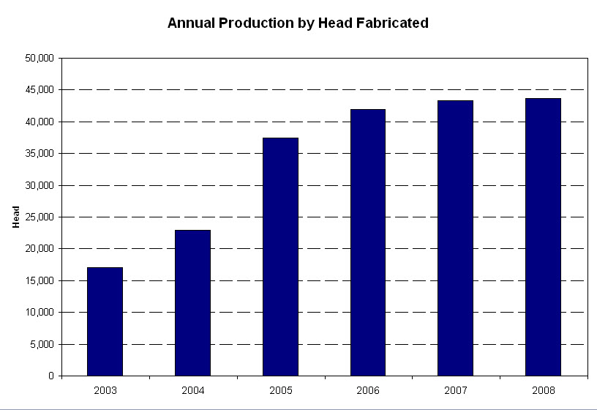

Exhibit 4: Country Natural Beef Annual Production

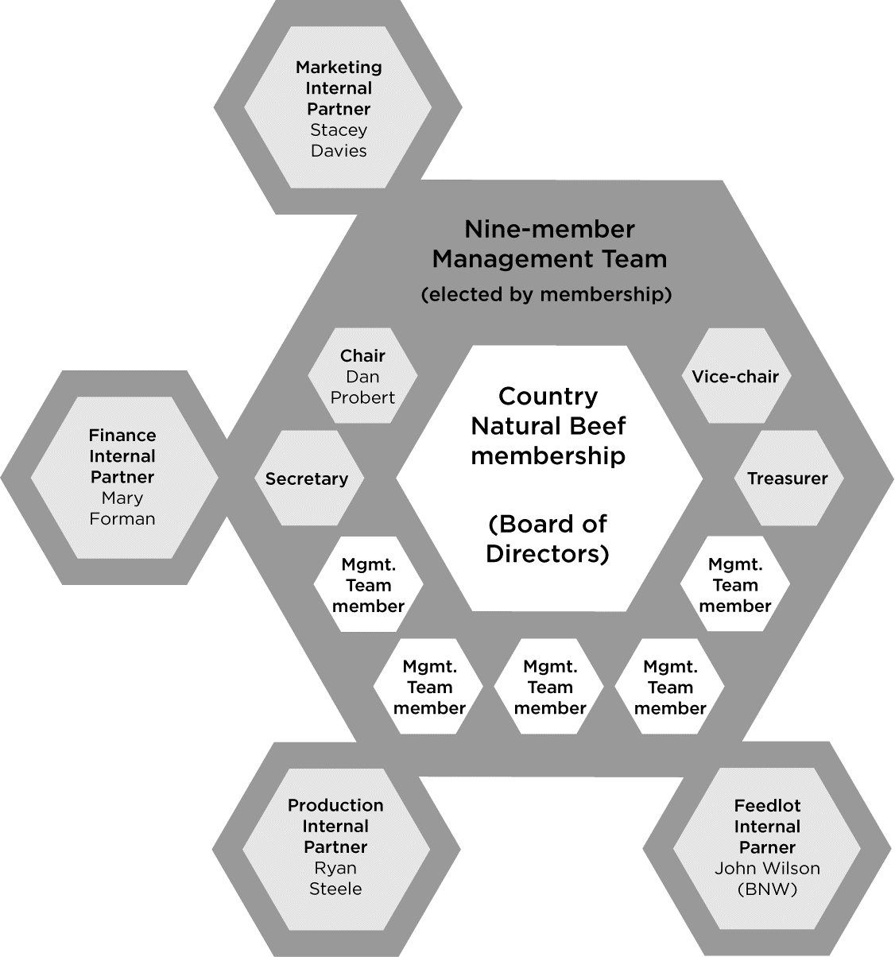

Exhibit 5: Country Natural Beef leadership structure. The management team officers and internal partners (shaded grey) make up the co-op’s leadership. John Wilson, the owner of Beef Northwest Feedlot, is a Country Natural Beef rancher and an internal partner because the critical role of the feedlot and his active engagement in the production operations of the co-op.

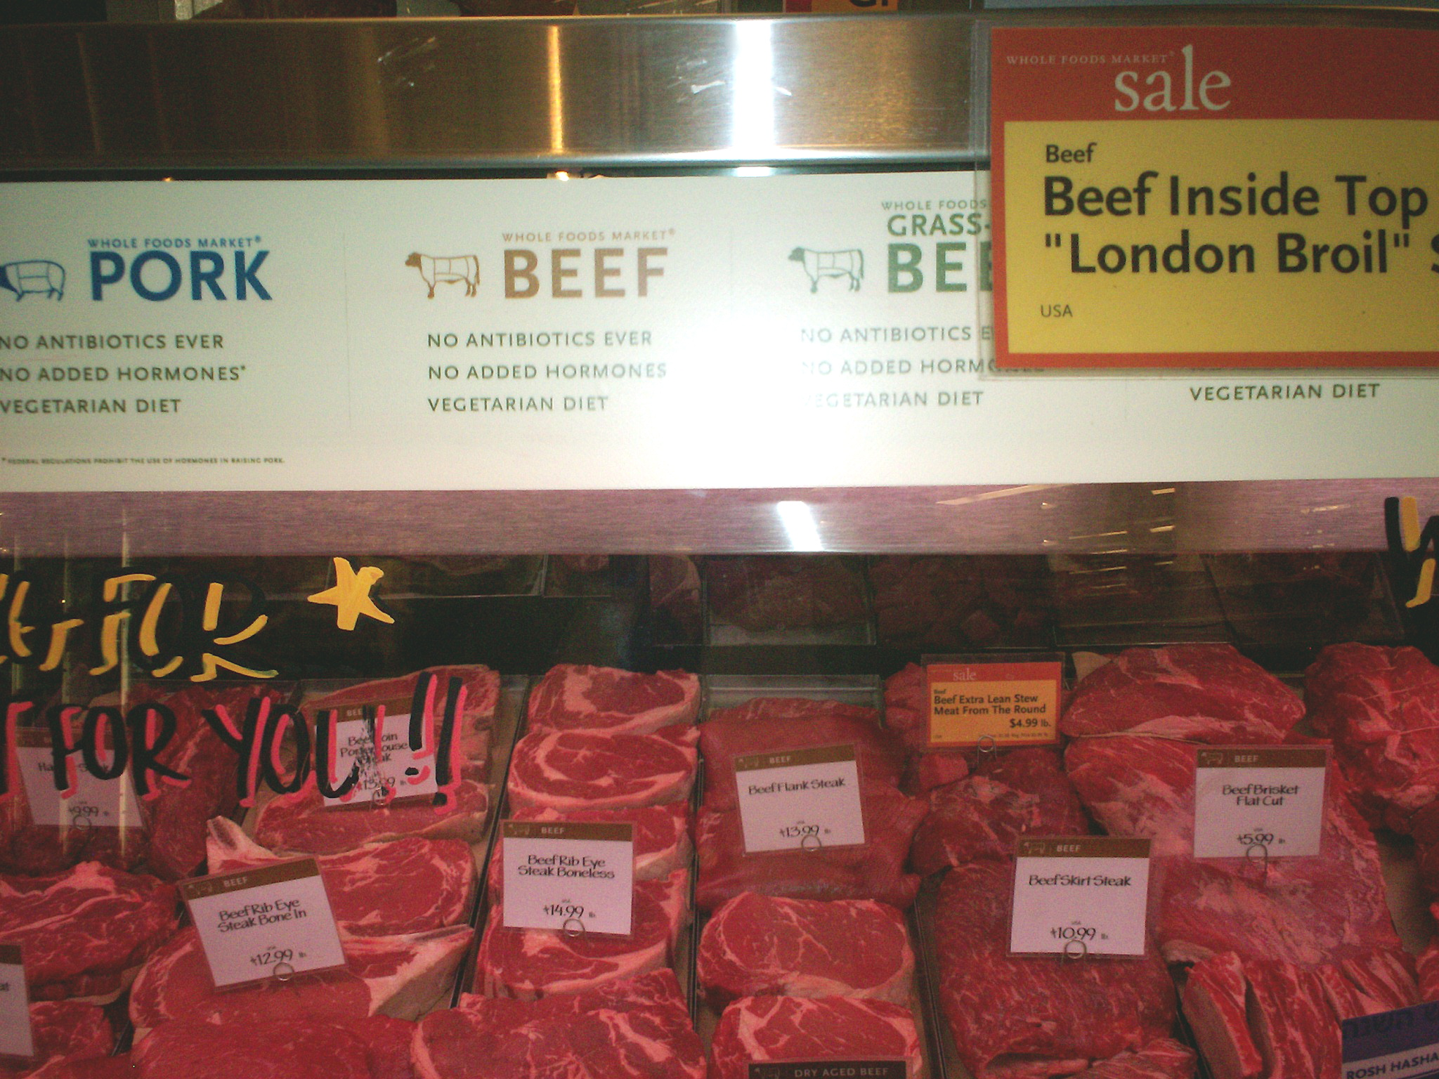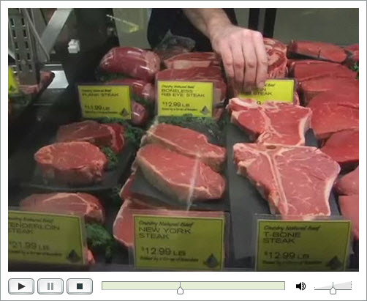

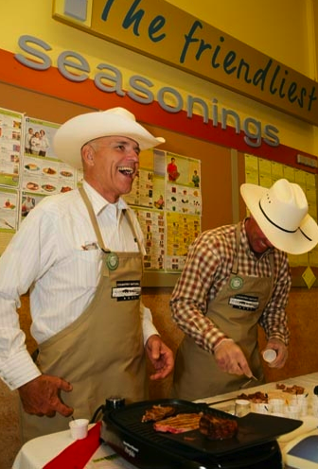

Exhibit 6: Marketing. Beef displays (top); Doc Hatfield and another rancher at an in-store demonstration (bottom)

Whole Foods, New Seasons, PCC
Retail Grocery
Aramark, Sodexho,
Bon Appétit
Institutional Purchasing

Foodservice
Burgerville
McMenamins
Restaurant Chains
Backgrounder
Lot
Services
Land Lease
Agents
Professional
Service
Providers

Feed Suppliers
Other input providers
Fulton Provision Co.
Portion Cuts Packer
Beef NW
Feedlot Finishers
Co-op Members
Rancher
Families
AB Foods
Slaughterer,
Carcass Packer
Out-of-Program Sales
Commodity Beef
Byproduct
Sales

Value Chain | Cow/calf | Background lot | Feedlot | Packer | Retailer
Unit | Ranch | Ranch | Beef NW | AB Foods & Fulton Foods (burger) | Retail Distributor:
CNB | Graze-well Principles & quality guidelines | Rules for In & Out of Program Cattle | Negotiates with Feedlot for financing. | Marketing negotiates with Processor based on CNB cost models  Finance receives final product data and compensation for beef. | Marketing negotiates contract with retail distributors, monitors transparency of credibility attributes
Rancher | Cow/calf timing, ranch management | Negotiates for feed cost and provides CNB criteria | Responsible for feedlot costs | Receives revenues from beef (commodity & placement) | Product demonstrations, interaction with customers
Verification | Food Alliance Cert | Food Alliance Certification | Feed Lot Audit | Food Alliance Cert.

Exhibit 7: Country Natural Beef Value Chain

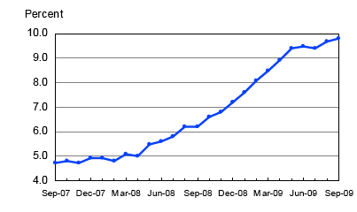

Exhibit 8: U.S. Unemployment Rate, Seasonally Adjusted ― Sept. 2009

(Source: Bureau of Labor Statistics, U.S. Department of Labor, 2009)

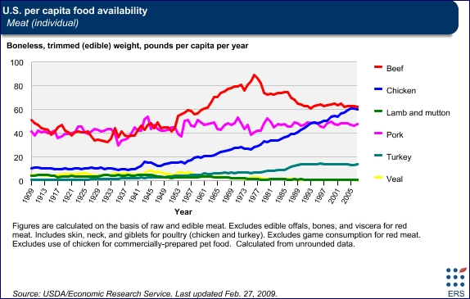

Exhibit 9: Beef Consumption Trends

(Source: USDA Economic Research Service, 2009)

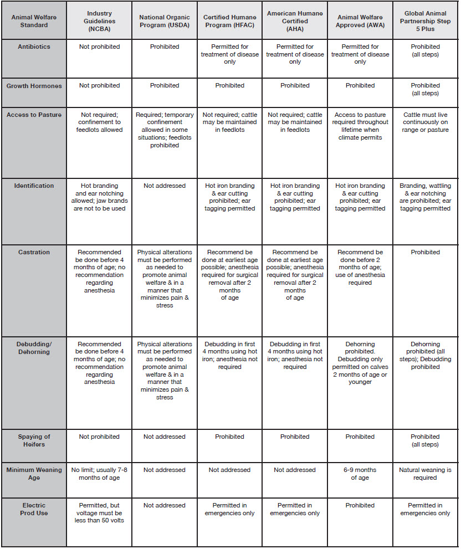

Exhibit 10: Comparison of Animal Welfare Standards by Program—Beef Cattle

(Source: Farm Sanctuary, 2009)

This case was made possible through the generous cooperation of Country Natural Beef Cooperative. The case is intended as a basis for class discussion rather than to illustrate either effective or ineffective handling of management situations. Copyright © 2011 by Madeleine Pullman, PhD. Portland State University, Portland, OR 97207 and Zhaohui Wu, PhD. Oregon State University, Corvallis, OR 97331. All rights reserved.
The Boardman facility uses potato byproducts from a nearby potato processing plant that furnishes fries to fast food chains.
For its fiscal year ending September, 2008
See http://www.laurasleanbeef.com for cattle specifications, bonus programs, and affidavit forms.

