Marketing Agricultural Products

Supply Chain Research 70 points

The objective of this project is to help you understand the supply chain of an agricultural product.

Read Chapter 11, “Marketing Channels and Distribution,” to get information on how marketing channels work and the many aspects of a distribution strategy (*Marketing Principles & Best Practices* by K. Douglas Hoffman, Thompson Advantage Books, Third Edition, 2006.)

Also read the article, “A Guide to Understanding the Value Chain.” This article gives you advice on looking at supply (value) chains from the agricultural producer’s point of view. (http://www.fruit.cornell.edu/Berries/marketingpdf/valuechain.pdf)

You also will need your notes on Values-based food supply chains: Value chains.

Your answers **must** be typed in 12 point font. Please have someone **proofread** your assignment.

**You must include a list of references and give credit to these sources in your text. 10 points will be deducted from your final score if there are no references or citations.**

Choose one of these 6 food products.

1. Bacon
2. Bread
3. Cheese
4. Ketchup
5. Applesauce
6. Peanut butter

If you would like to choose a different food product, you must get my approval. You cannot choose a product that is marketed directly from the producer to the consumer.

For the food product you have chosen describe the seven (7) levels of its supply chain by answering 1 through 7 below. Make sure you respond to all of the instructions for each of the seven levels.

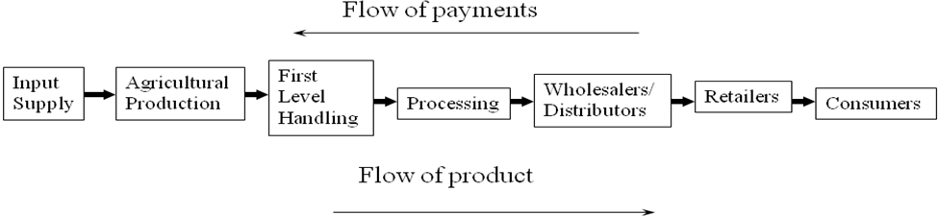

1. (6 points) Input supply
2. Describe all of the inputs that are needed for agricultural production of the raw material for your product.
3. Where does the farmer obtain these inputs?
4. Are there a large number of input suppliers? Why or why not?
5. Are there any dominant companies at the input supply level of this supply chain?
6. Explain any key technological advances related to your product at this level of your supply chain.
7. (13 points) Agricultural production
8. Describe the production process for the main agricultural raw material that goes into your product.
9. How long does it take to produce this raw material? How do you know when it is ready to be harvested? How is it harvested?
10. What production risks could impact agricultural production of your raw material?
11. Discuss the perishability of your raw material. How does perishability impact the logistics and handling of your raw material at this level of your supply chain?
12. Explain any key technological advances related to your product at this level of your supply chain.
13. How many U.S. farms produce the raw material for your product? What percentage is this of the total number of farms in the U.S.? You can find the numbers you need here:

http://www.agcensus.usda.gov/Publications/2007/Full_Report/Volume_1,_Chapter_1_US/index.asp

1. (4 points) First level handling
2. Describe the first place the raw material goes after it leaves the farm.
3. Do farmers have many choices about where to sell their product at this level? Explain.
4. Are there any dominant companies at the first handling level of the supply chain?
5. (13 points) Processing
6. Describe the process that turns the agricultural raw material into the food product that people will eat.
7. What other ingredients become parts of the final consumer product?
8. What type of packaging is used for this product? Discuss how packaging might vary by target market.
9. What production risks could impact processing of this food product?
10. Discuss the perishability of your product after it is processed. How does perishability impact the logistics and handling of your product at this level of your supply chain?
11. Explain any key technological advances related to your product at this level of your supply chain.
12. Are there a large number of processors of this product?
13. Who are the major companies that produce this product in the U.S.?
14. Are there any dominant companies at the processing level of the supply chain?
15. (5 points) Wholesalers and/or distributors
16. How is this product distributed once it leaves the processing facility? Discuss the possibilities for all of the following distribution options.

* The product could be distributed by the processor.
* The product could go to an independent wholesaler who then sells the product to retailers.
* The product could go to a distribution system run by the retailer.

1. (5 points) Retailers
2. At what retail operations can a consumer purchase this product? Describe all of the possibilities (including foodservice).
3. Are there a large number of retail and/or foodservice outlets?
4. Are there any dominant companies at this retail level of the supply chain?
5. Explain any key technological advances related to your product at this level of your supply chain.
6. (14 points) Consumers
7. Describe how this product is used by consumers.
8. Do a large number of consumers eat this product? Explain.
9. What group of consumers would not eat this product and why?
10. If you were a producer of this product, who would be your target market and why? Describe the demographic, geographic and psychographic characteristics of your target market.
11. What are the important consumer trends related to your product?
12. Is this a product that is growing in popularity? Why or why not?
13. Are the types of consumers buying your product changing? How might changing demographics or psychographics impacting demand for your product?
14. How could you differentiate your product from that of your competitors to win consumers for your brand?
15. (4 points) Competition
16. What other supply chains for substitute products does your supply chain compete against? (This means food products that can be substituted for bacon, or bread, or cheese, or ketchup, or applesauce, or peanut butter.)
17. Discuss all of the possibilities and remember competition may not come from where you expect it.
18. (6 points) Values-based food supply chains
19. For your product, how might agricultural production be different in a values-based food supply chain compared to a mainstream food supply chain?
20. How might the product be differentiated in a values-based food supply chain compared to a mainstream food supply chain?
21. Describe the characteristics of the business relationships between participants in the various levels of a values-based food supply chain compared to a mainstream food supply chain.